PowerBI Dashboards explained

Streaming Predictive Maintenance Demo

Last updated: 9/18/2017

# REAL-TIME DASHBOARD

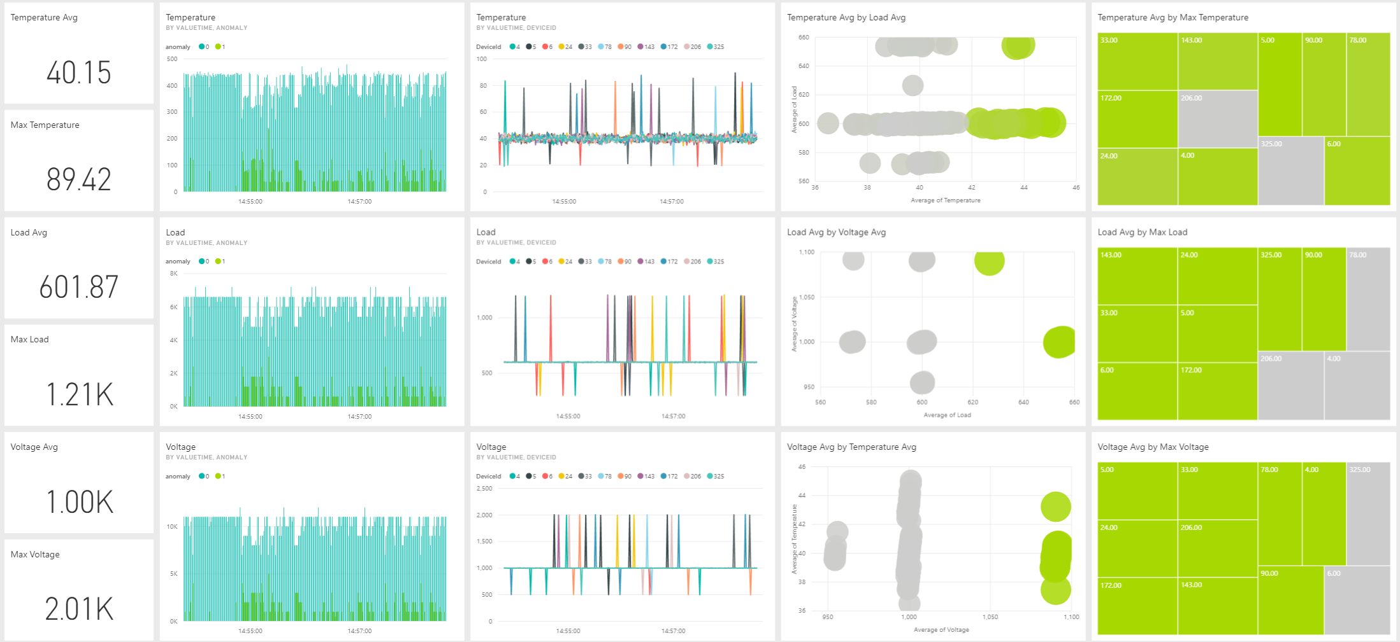

The real-time dashboard shows the following device metrics: temperature, load percentage and voltage. Each of these metrics are represented with the following tiles:

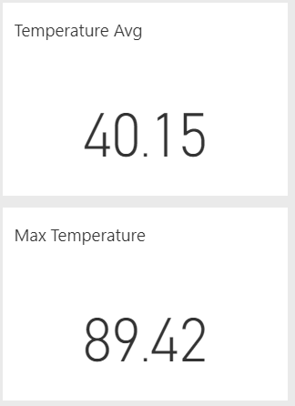   
**Average and Maximum**: As the title says, they show the average value and the maximum value for the given metric of all the data that has been collected until that moment.

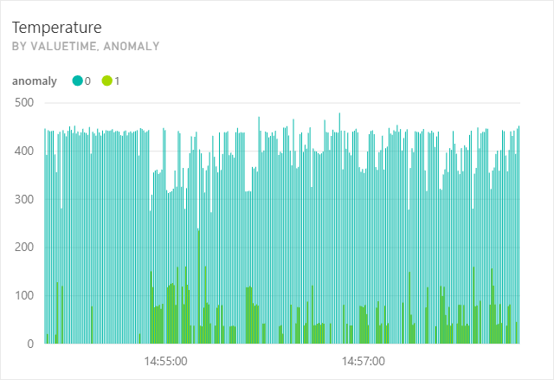

**Anomalies by time:** Shows the metric values sent by the devices, highlighting them as an anomaly or not.

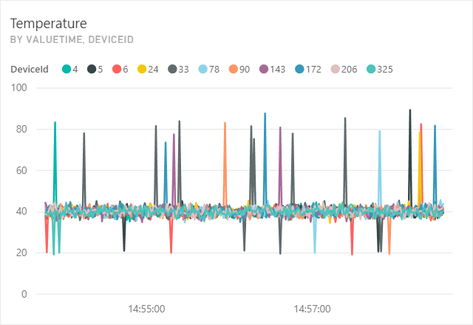

**Metric by time and device:** Shows the metric values sent by the devices over time, highlighting them with a different color per device.

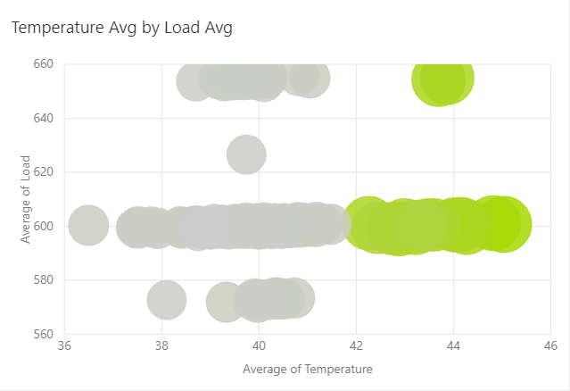

**Average by another metric average:** Shows the average of a metric according to another metric average for each device. Also, it allows to analyze the maximum value of such metric. The higher the maximum, the *greener* the circle. The lower the maximum, the *greyer* the circle.

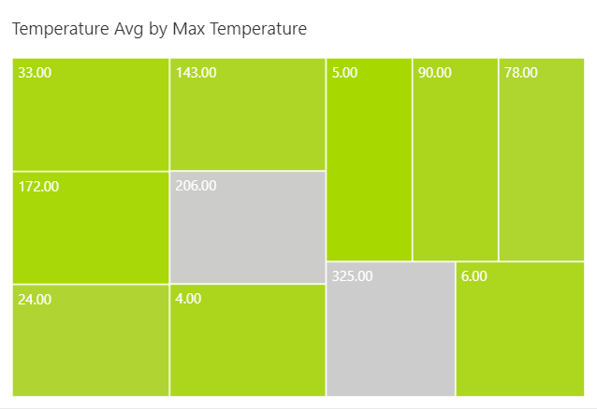

**Average by metric maximum:** Shows how the average looks according to the maximum value received per device. Each device is represented by a single square. The higher the average, the bigger the square. The higher the maximum, the *greener* the square. The lower the maximum, the *greyer* the square.

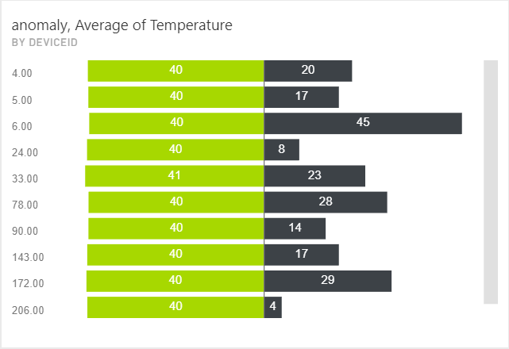

**Anomalies and average by Device:** It shows the average of those values that are anomalies and for those which are not.

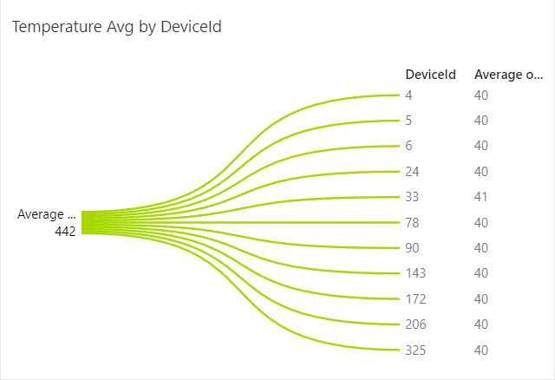

**Average by Device:** It shows the average value for a given metric for each device.

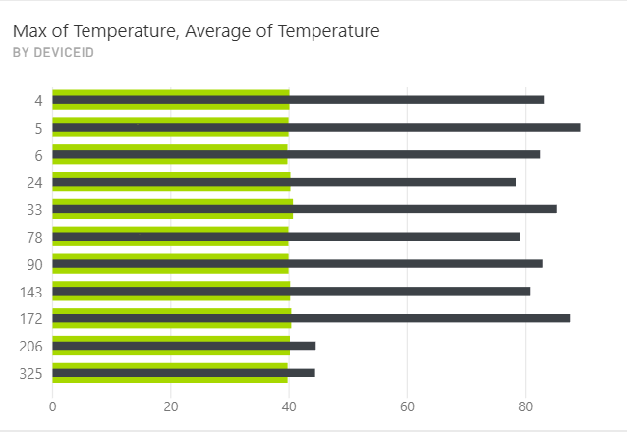

**Maximum and average by Device:** It shows the average value and maximum value for a given metric for each device.

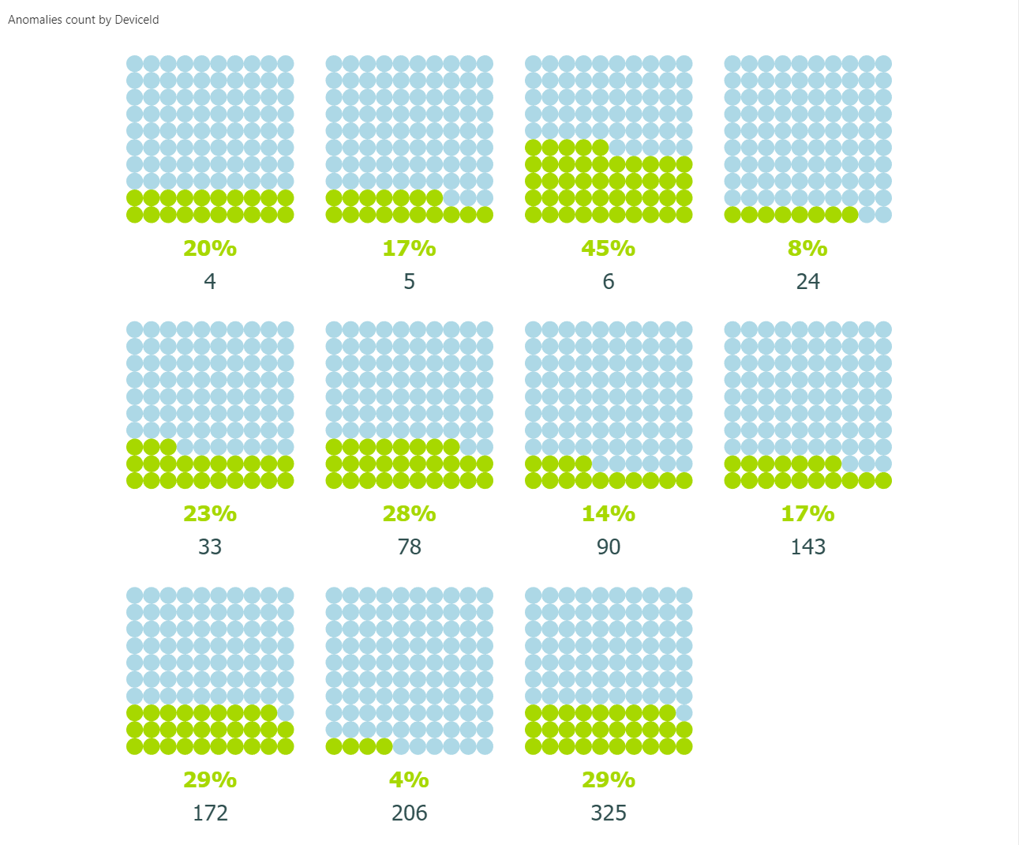

**Anomalies by Device:** It shows the percentage of anomalies for each device.

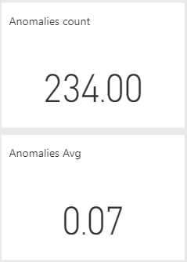

**Anomalies count:** It shows the number of anomalies predicted using the data sent from all the devices.

# batch DASHBOARD

The batch dashboard is divided in three different reports.

## Anomalies by Asset

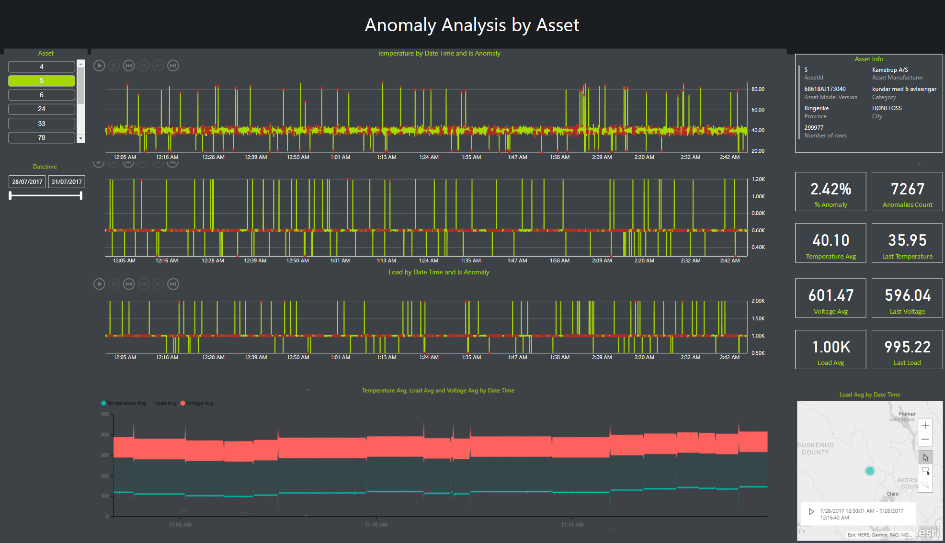

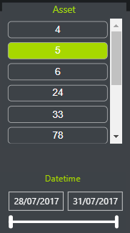

**Asset selector:** Used to filter the data shown by asset. Also, it can be specified dates between data should be retrieved.

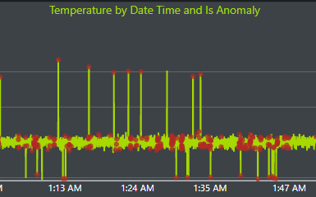

**Metric by date and anomaly**: Shows values for a particular metric over time, and also highlights values which are considered anomalies.

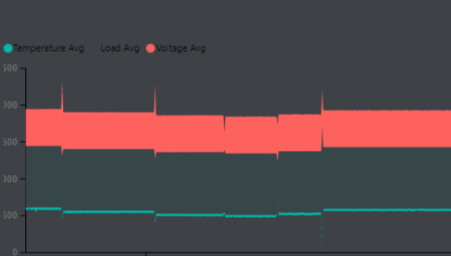

Average of all metrics by date: Shows the average value for all the metrics over time.

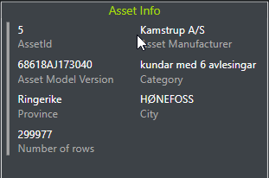

Asset info: Shows information about the asset selected.

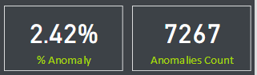

Anomalies counter: Shows the number of anomalies received for all the metrics, and the percentage of values considered as anomalies among all the data received.

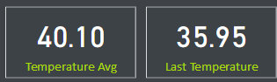

Metric average and last value: Shows the average for a particular metric and the last value received.

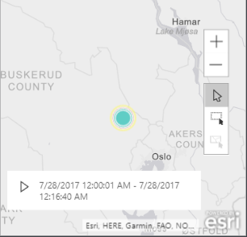

Asset location: Shows in a map where the selected asset is located.

## Anomaliy Analysis

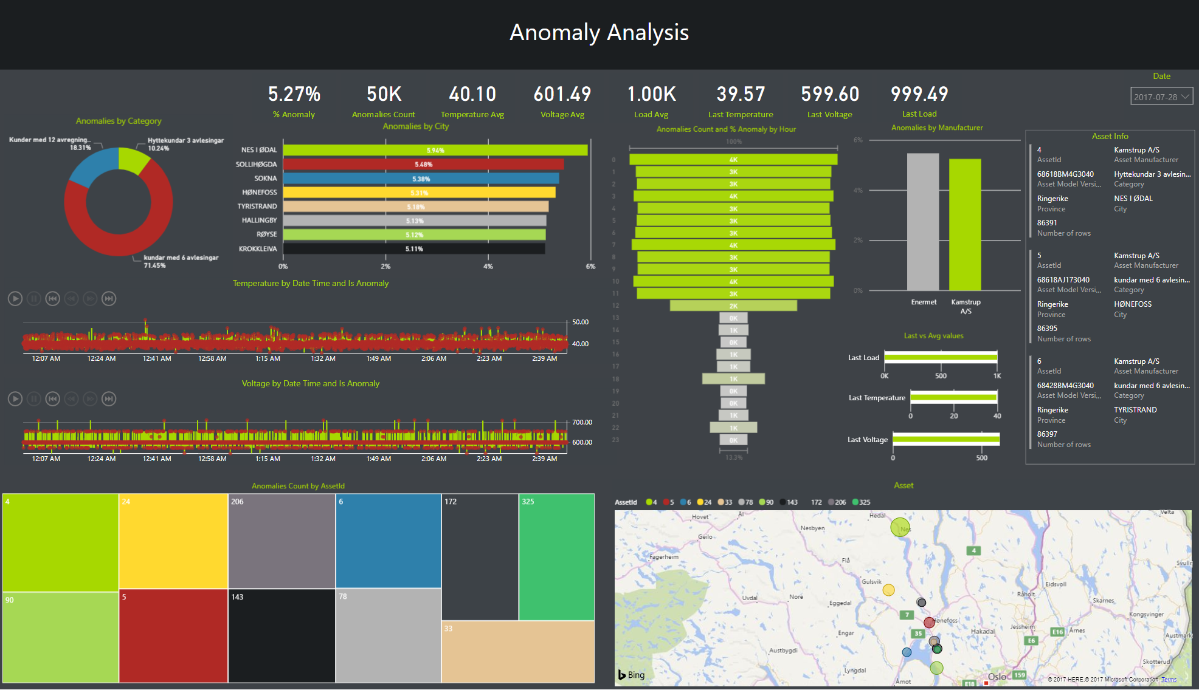

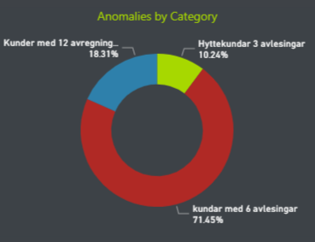

Anomalies by category: Shows the percentage of anomalies in each asset’s category.

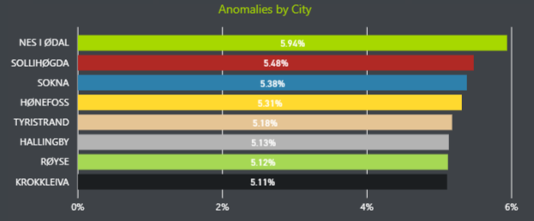

Anomalies by city: Shows the cities with most anomalies.

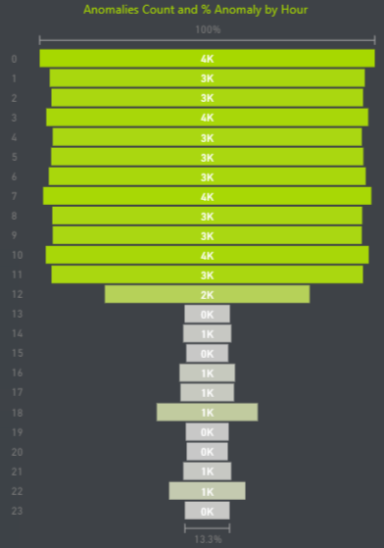

Anomalies by hour: Shows the number of anomalies received each hour of the day.

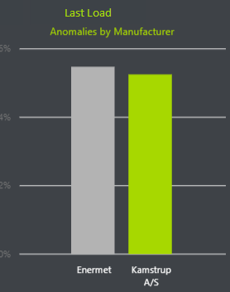

Anomalies by manufacturer: Shows the percentage of anomalies produced by the companies that produce the assets. The greener, the greater number of anomalies.

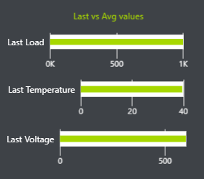

Comparision of Last and average values: Shows a comparision between the last value received for each metric and the average.

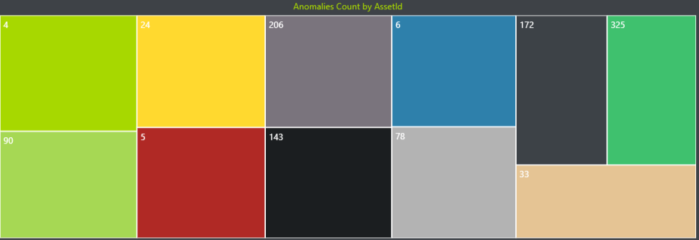

Number of anomalies by asset: Each square represents an asset. The bigger the square, the greater the number of anomalies detected in that particular asset.

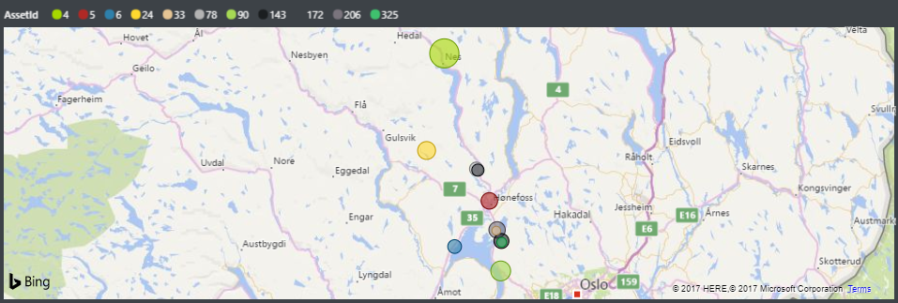

Asset locations: Shows all the assets analyzed with anomalies in the map.

## Asset classification

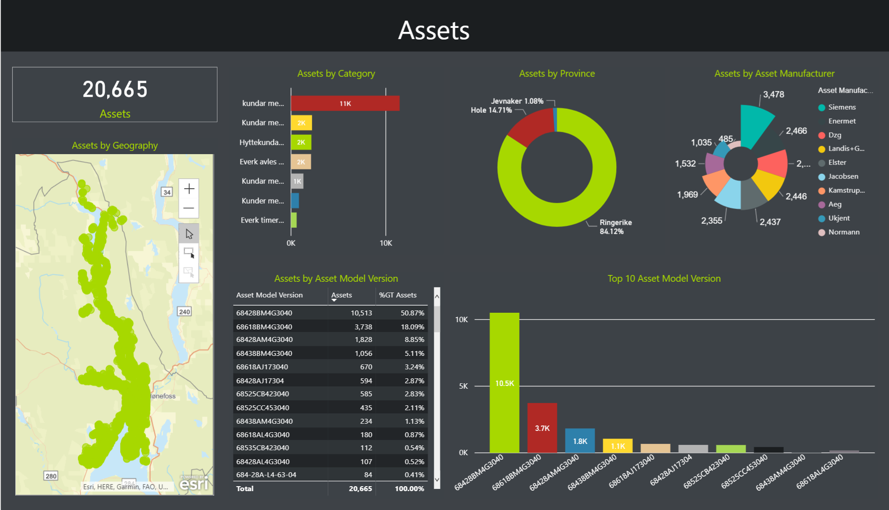



Asset count: Shows the total number of assets.

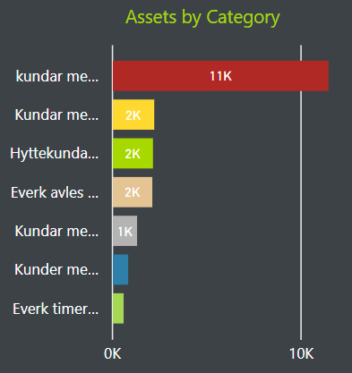

Assets by category: Shows the number of assets in each category.

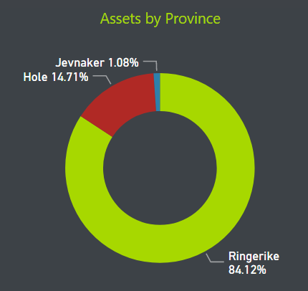

Assets by Province: Shows the number of assets in each province.

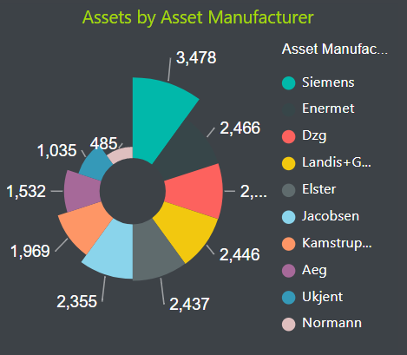

Assets by Manufacturer: Shows the number of assets created by the differents manufacturers.

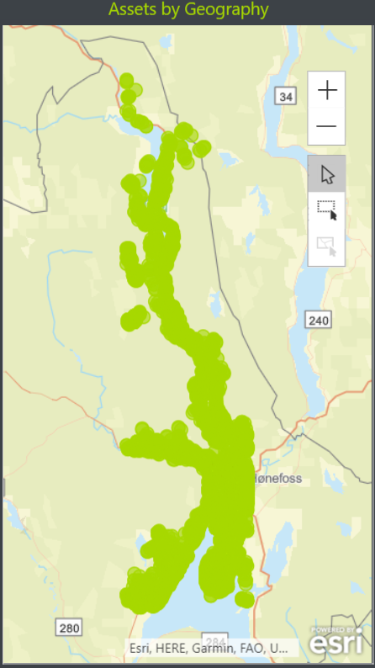

Assets by Geography: Shows how the assets are distributed in a map.

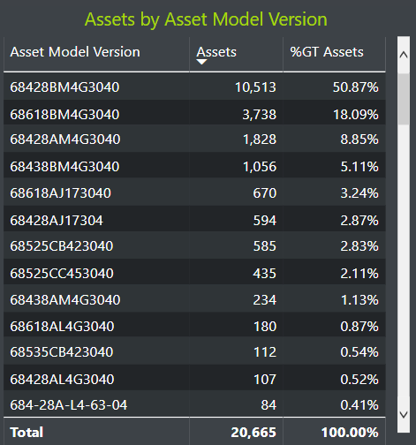

Assets by model: Shows the number of assets classified by their version.

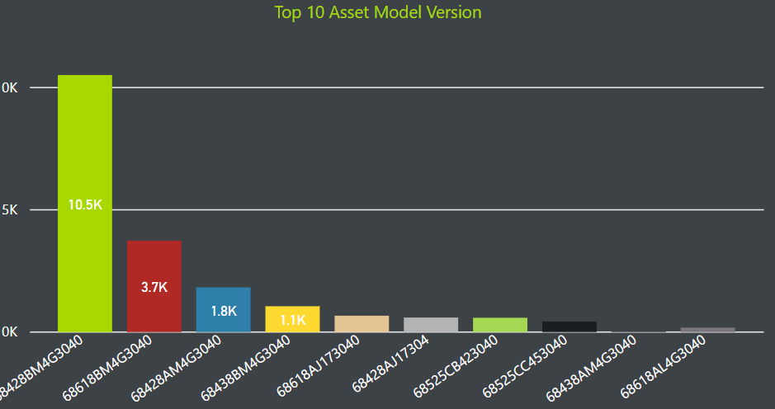

Top 10 assets’ model: Shows the models with most number of assets.